BIOS 6611
Biostatistical Methods I

SAS Lab 1 exercises

1. The data in the table below are a sample of scores on the Duke Unified Parkinson’s Rating Scale (DUPRS), a global measure of impairment due to Parkinson’s disease, a progressive neurologic disorder resulting from the inability to produce dopamine, a neurotransmitter responsible for motor and cognitive function. Higher scores indicate greater motor and/or cognitive impairment. The scores were obtained before and after enrollment for 10 months in a clinical trial comparing three exercise programs.

Using SAS (see Lab 1):

- Construct a frequency distribution for the change data.
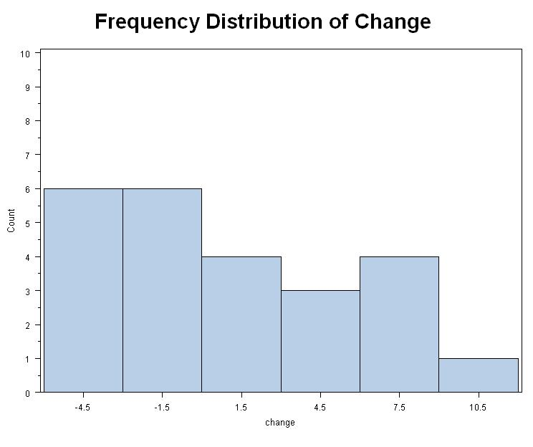
- Comment on the symmetry of the distribution. The frequency distribution is more or less unimodal and appears to be positively skewed (to the right).
- Investigators would like to test the hypothesis that the effects of exercise on cognitive and motor function are more evident in people with high rather than low DUPRS scores. Explore this in two ways and comment:
i. Split the data in the table according to whether baseline (before) DUPRS score is above or below the median, and examine the two groups.
----------------------------------------- indic=lower ------------------------------------------

Obs before after

1 4 5
2 8 10
3 11 13
4 12 15
5 10 5
6 11 8
7 21 21
8 14 18
9 21 20
10 11 19
11 17 23
12 18 25
13 7 6
For the indicator before < 21 (the median), the following descriptive statistics for the change were calculated as follows: mean is 1.77, median is 2.00, and the standard deviation is 3.85.
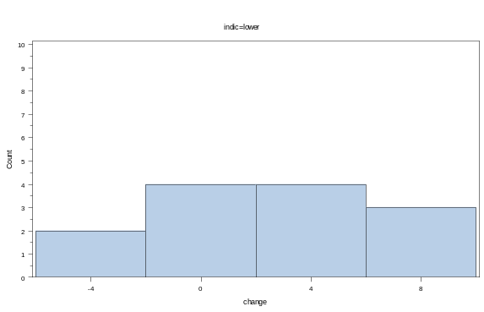
The distribution appears symmetrical.
----------------------------------------- indic=upper ------------------------------------------

Obs before after

14 24 19
15 36 44
16 22 18
17 23 19
18 26 24
19 28 31
20 23 33
21 29 25
22 26 25
23 36 31
24 30 27

For the indicator before > 21 (the median), the following descriptive statistics for the change were calculated as follows: mean is -.64, median is -3.00, and the standard deviation is 5.30.
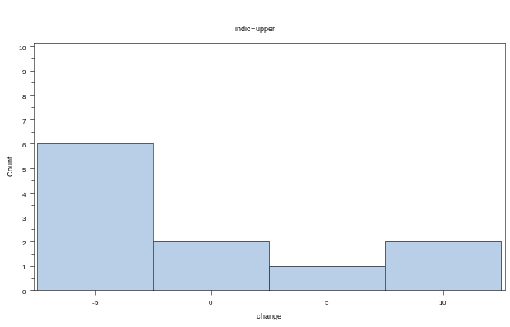
The distribution is unimodal and appears positively skewed (to the right).

The two groups appear to differ with regard to mean change, with the group that’s lower at baseline experiencing greater change for the worse.

- Plot the change on the vertical axis versus the before value on the horizontal axis and examine the graph. (It is actually better to plot versus the average of before and after, but for simplicity use before.)
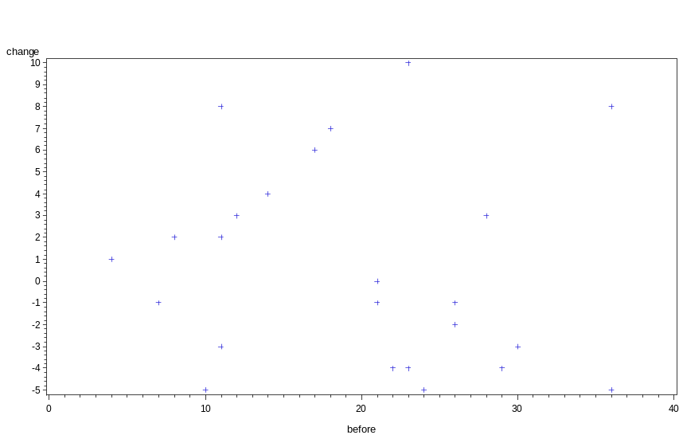
The data points are scattered randomly without an obvious trend between change and baseline values. However, when looking at the scatter of values above vs. below the median at baseline, it can be seen that the patients whose baseline values are lower tend to experience greater change for the worse.

Subject | 1 | 2 | 3 | 4 | 5 | 6 | 7 | 8 | 9 | 10 | 11 | 12
Before | 4 | 24 | 8 | 36 | 11 | 12 | 22 | 10 | 23 | 11 | 26 | 21
After | 5 | 19 | 10 | 44 | 13 | 15 | 18 | 5 | 19 | 8 | 24 | 21
Subject | 13 | 14 | 15 | 16 | 17 | 18 | 19 | 20 | 21 | 22 | 23 | 24
Before | 14 | 21 | 11 | 17 | 18 | 28 | 23 | 29 | 26 | 36 | 30 | 7
After | 18 | 20 | 19 | 23 | 25 | 31 | 33 | 25 | 25 | 31 | 27 | 6

2. You are presented with data for 100 low birthweight (weight < 2500 gm) infants. The information includes: systolic blood pressure (SBP), gender (SEX), toxemia (pregnancy-induced hypertension) in the mother (TOX), germinal matrix hemorrhage in the infant’s brain (GRMHEM), gestational age (GESTAGE) and Apgar score at 5 minutes (APGAR5) (Designed in 1952 by Dr. Virginia Apgar, the APGAR score is a quick test performed at 1 and 5 minutes after birth to determine the physical condition of the newborn. The rating is based on a scale of 1 to 10. A rating of 10 suggests the healthiest infant, and scores below 5 indicate the infant needs immediate assistance in adjusting to the new environment).

Source: Pagano, M. and Gauvreau, K (1993). Principles of Biostatistics. Belmont, CA: Duxbury Press.

Reference: Levito, A. et al. (1991). Labor and Delivery Characteristics and the Risk of Germinal Matrix Hemorrhage in Low Birth Weight Infants. Journal of Child Neurology, 6:35-40.

A summary of descriptive analyses was obtained to answer the following questions about systolic blood pressure (SBP) in these low birthweight infants. You can find these in the document with the listing of the data. Be sure to use the appropriate numbers from the document to support your answers. Hand in only the homework document with your answers. Do not attach the analysis document.

- What are the mean and the median SBP for males? For females?
Answer:
Males: Mean 47.9 mmHg, Median: 46 mmHg
Females: Mean 46.5 mmHg, Median: 47 mmHg

- Are the distributions of SBP in these groups symmetric or approximately so? Why or why not?
Answer:
Since the distributions are unimodal, we can compare the mean and median (mode, too, but less useful), and also look at the histogram and the box plot to assess symmetry. The female distribution looks fairly symmetric while the male distribution is slightly positively skewed.

- What would be the effect (increase, decrease, no effect) on the male mean, median, mode, s.d., range and IQR of an additional SBP observation of 98 mm Hg? Of 10 mm Hg? Of 44 mm Hg? (Note: No additional SAS manipulations are required to answer these.) (NB: The emphasis of this part of the question is on concepts, not calculations.)

Answer:
 | 98mmHg | 10mmHg | 44mmHg
mean | increase | decrease | stay about the same
median | stay about the same | stay about the same | stay about the same
*mode | no change | no change | no change
s.d. | increase slightly | increase slightly | stay about the same
range | increase | increase | no change
IQR | increase slightly | Increase slightly | stay about the same

* hard to really tell about the mode without checking the actual data

- Between what two values of SBP are the middle 50% of males included?
Answer:
The middle 50% of males are included between 41 mmHg (25%/Q1) and 52.5 mmHg (75%/Q3) of SBP.

- What is the 90th percentile of SBP for females? For males?
Answer:
62.0 mmHg is 90th percentile of SBP for females. 64.0 mmHg is the 90th percentile of SB for males.

- What kind of variable is SBP? Gender? SBP recoded as Low, Moderate, High?
Answer:
SBP: continuous variable on a ratio scale
Gender: nominal variable
SBP recoded as Low, Moderate, High: ordinal variable

- What would be the effect on the mean female SBP of an instrument used to measure SBP that reads 7 mm Hg high consistently? Effect on the female s.d.?
Answer:
Mean will increase 7 mmHg.
S.D. will not be affected.

- What would the effects be on the above mean and s.d. if we wanted to convert the original SBP readings to be like readings by a different instrument according to the following: 0.98 SBP + 7 mm Hg?
Answer:
Mean will become 0.98×mean+7 mmHg.
S.D. will become 0.98×s.d. mmHg.
Note: According to Mean and variance properties
.
- Suppose the data had been “censored” by not recording SBP lower than 30 mmHg, so that any missing value is known to be below 30 mm Hg but the exact value is not known. With censored data, it is not typically acceptable to insert the limit value (30 here), nor is it acceptable to ignore the censored observation in the calculation. For each of the parameters in (c) above, could it still be calculated? Explain briefly.

Answer: NOTE: This can be based on the group overall or just females or just males.

Mean – The mean could not be calculated as the SBP values would not be available below 30 mmHg. The mean requires that all of the values of SBP be averaged, so all values must be known.
Median – The median could potentially be calculated since the number of observations could still be counted to find the middle value. The median could be found as long as the number of observations less than 30 mmHg was less than n/2.
Mode – The mode could not be calculated since the actual numbers of observations at each value need to be known.
s.d. – The standard deviation cannot be calculated as this depends on knowing the mean and the
individual values of each observation.
Range – The range cannot be calculated. We would know that the range is greater than or equal to the largest observed SBP – 30.
IQR – The interquartile range could be calculated for this data set since all the values less than 30 mmHg are below the 25th percentile. If the censored values comprised more than 25% of the sample, then IQR could not be calculated.

To think about for future analysis: (no written response required for this assignment):

- What questions do you have about the data?
- What hypotheses (questions) might you pose using these data?
- What are some limitations you could foresee about addressing those hypotheses using these data?



